Amran Uddin

fv9000

CSC 4996

To Do List Documentation

This program uses php to connect to a MySQL database to add, delete, and view entries from the database. Its purpose is to be used as a simple to do list.

Functional Requirements

* Add Task – This function takes user input and inserts it into the database. The user input inserted into the database along with an incrementing primary key. This key identifies the input.
* Delete Task – This function takes an integer value from the user and tries to delete an entry from the database which matches the primary key.
* View Tasks – This function shows all the data in the database and presents it in a table. The values shown are the task numbers and the task name.

Non-Functional Requirements

* Program should be able to output all the data in the database based off the number of total rows in the database. Its runtime should be O(N).
* The database should be able to store at max 50 characters in each task name column.
* The program should be able to run when Apache and MySQL are running.

System Architecture Diagram

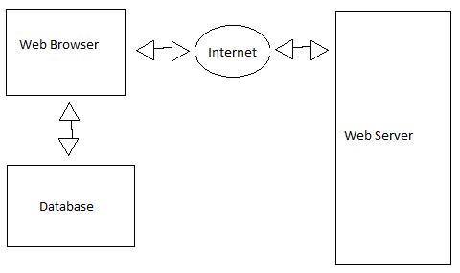

Data Flow Diagram

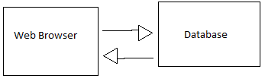

Use Case

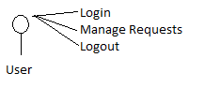

Sequence Diagram

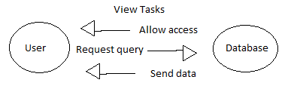

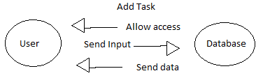

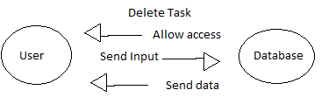

Database Design

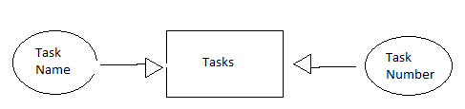

Test Case

|  |  |
| --- | --- |
| Summary | Test the view function |
| Procedure | Click the view tasks button with no data in database and with data in database |
| Test Data | No data and 3 entries |
| Expected Results | Display the data in database. If none, the output should be no tasks |
| Actual Results | Displayed the data when in database and displayed no tasks when no data in the database |

|  |  |
| --- | --- |
| Summary | Test the add task function |
| Procedure | Input a string into the text box and click submit |
| Test Data | String value is task1 |
| Expected Results | Output is 'Task1' was successfully added |
| Actual Results | Output is 'Task1' was successfully added |

|  |  |
| --- | --- |
| Summary | Test the delete function |
| Procedure | Create three entries in the database. Then delete the created task |
| Test Data | String value task1, task2, task3 |
| Expected Results | Successfully deleting all tasks and displaying the remaining task |
| Actual Results | Deleted the tasks while displaying all the data in the database |